PRIMARY SCHOOLS
Dear All,
Edinburgh University, in collaboration with the Spanish Consulate, is going to launch the first Edinburgh Spanish Film Festival (ESFF) from 8th - 12th October this year.
We are currently planning our programme and would like to include an animation film particularly suitable for primary school pupils (P6 and P7), if there is an audience.
I am writing to you to know if your school will support us by bringing children to see an animation film at the Filmhouse on the morning of the 8th of October around 10 am.

The film will be followed by a workshop at the ECA (Edinburgh School of Arts) – around 30 children for the workshop. The children will learn how to make an animation film using the same props and materials that students of Animation use. Each group will produce a short film of 1 or 2 minutes. The children will need to work on ideas prior to going to the workshop so that the work produced is worthy and well prepared.

The cost for the film and the workshop will be £5 per child
The cost for the film only will be £2.60 per child teachers free.

This is a great opportunity for the children to experience watching a film with subtitles and also to create their own film.

We need to know now in order to get the ball rolling. Could you therefore please reply asap by answering the following questions:

- Yes, this is a good idea and we will bring around ..........pupils.
- Yes, we would like to book a place on the 8th for……pupils for the film only.
- . Yes, we would like to book a place for the 8th ……pupil for the film and workshop.
- The date or time is not appropriate for us. It would be better on the 9th or 10th October at......

If you want to book a place you will need to pay a deposit £100
Please don't hesitate if you need to contact me for more information.

Thank you for your collaboration.

Yours Sincerely,

Marian A.Aréchaga
Marian.esff@ed.ac.uk
Info.esff@ed.ac.uk
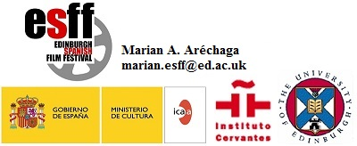
-- The University of Edinburgh is a charitable body, registered in
Scotland, with registration number SC005336.

